**Activités extrascolaires 2**

1. **Qu’ est-ce qu’ils font ?**

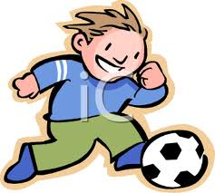[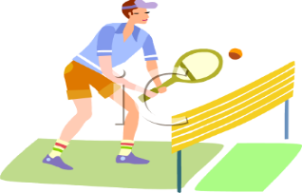](http://www.google.com.cy/url?sa=i&rct=j&q=tennis+CLIP+ART&source=images&cd=&cad=rja&docid=uj0aO5pBEDcrcM&tbnid=PuBWzk8Enwe5LM:&ved=0CAUQjRw&url=http://bestclipartblog.com/28-tennis-clip-art.html/tennis-clipart-7&ei=t0UlUdavF6qZ0QWS_oCoDw&bvm=bv.42661473,d.d2k&psig=AFQjCNEeMWXjMkT6vlmSV1aN6vXHuHbosg&ust=1361483552348661)[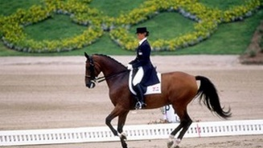](http://www.google.com.cy/url?sa=i&rct=j&q=ippasia&source=images&cd=&docid=lepeGcSnC28FOM&tbnid=OQr3iUZLSKjBYM:&ved=0CAUQjRw&url=http://www.sport24.gr/Sports/OlympicGames/article319294.ece&ei=6vBGUZnHC4m_PODegZgG&psig=AFQjCNELeA4Afyz6JC0i3cIObrM-4g-0Zw&ust=1363690079413050)

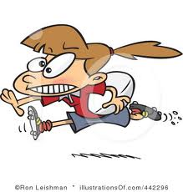[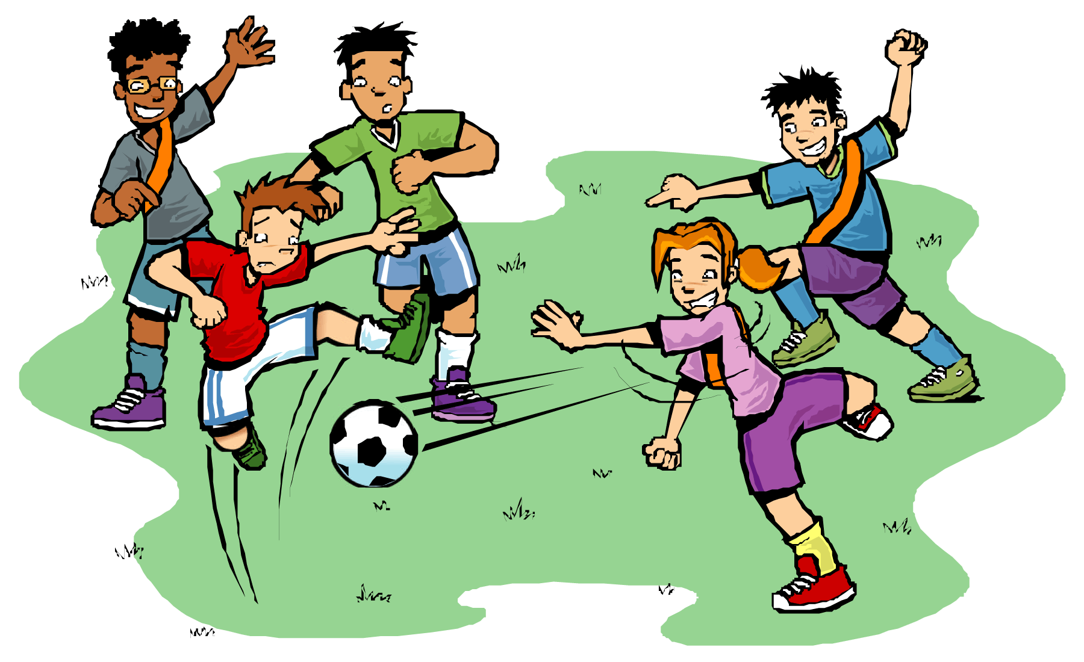](http://rukusavenue.com/wp-content/themes/twentyten/children-playing-football-clipart-i18.gif)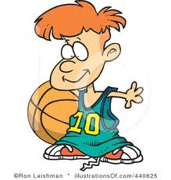  
a. _____________________ b. ____________________ c. ___________________

d._____________________ e. ____________________ f. ___________________

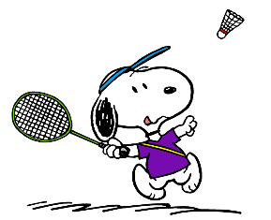

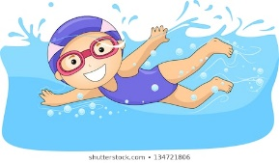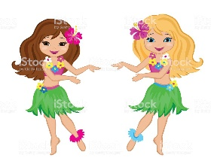

g._____________________ h. ____________________ i. ___________________

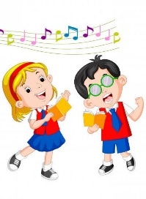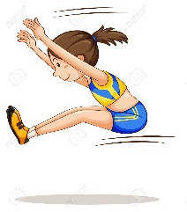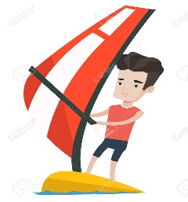

j._____________________ k. ____________________ l. ___________________



Bon travail !!!